

2017-2018 Sponsors

R.B. Hunt Business Partners

Principal Donors

[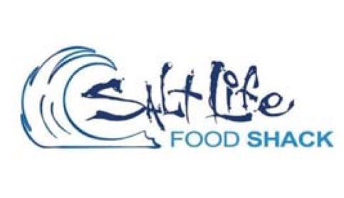](http://www.saltlifefoodshack.com)[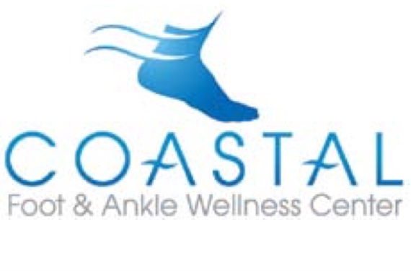](http://www.coastalfaa.com)

Beacon Donors

[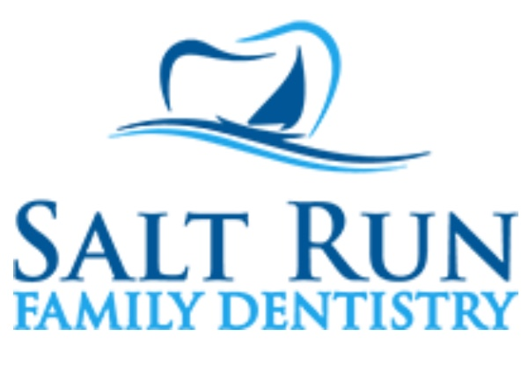](http://www.saltrundental.com)[](http://www.dianesnaturalmarket.com)[](http://www.townederm.com)[](http://www.littlesmilesfl.com)[](http://www.whiteroomweddings.com)[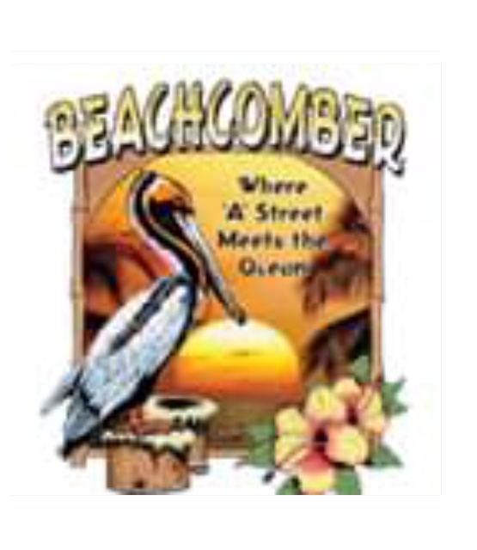](http://www.beachcomberstaugustine.com)

[](http://www.perryunwalla.com)[](http://www.troikastudio.com)

[](http://www.PartyStAug.com)[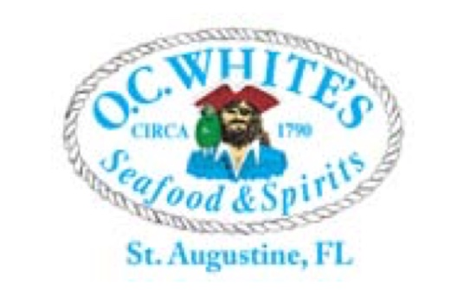](http://www.ocwhitesrestaurant.com)[](http://www.brightway.com)[](http://www.gordon-dental.com)[](http://www.birhallandco.com)[](http://www.growersalliance.com)

Lighthouse Donors

[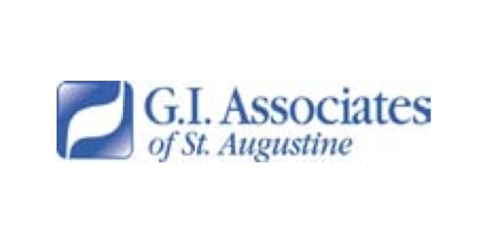](http://www.gi-associates.com)

Islander Donors

[](http://www.starsrehab.org)[](http://www.saintaugustinelawyer.com)[](http://www.recycledkids.net)[](http://www.behstbuilers.com) 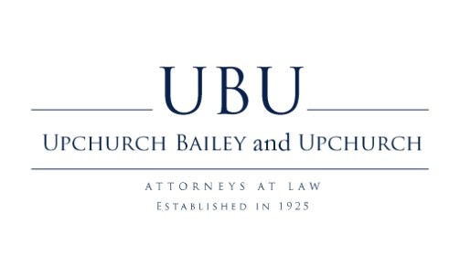

Charlambous Family

Red & White Donors

Southeast Sports The Bell Family