Frequently Asked Questions for Kindergarten Parents
“Meet the Teacher” - Thursday, August 7th 5:30-7:00p.m. Enter through the cafeteria, there will be information on bus routes, you may get a car rider card, lunch account information, information on P.T.A.O. and school spirit ware for sale. You will receive a letter in the mail with your assigned teacher.
Modified Start for Kindergarten
Monday, Tuesday and Wednesday we will have one third of the class attend to allow teachers to have a small group of children to work with so they can get to know each child and gently introduce them to our school routines. You will receive another email with a sign up for either of the three days.
During the modified start you may walk your child to their class and stay with them until parent orientation starts. The orientation will last approximately 45 minutes, and we will be available for questions after. Enter through the cafeteria and get a badge and proceed to your child’s classroom.

School Day Time: 8:25-2:45-M, T, TH, F. 8:25-1:45 on Wednesdays
Dropoff line is open at 7:45. Early morning care begins at 6:45 am.
School news show- 8:20
Students “tardy” at 8:26.
All “car riders” and “walkers” enter through the cafeteria door. Bus riders will enter through the bus loop. Students are supervised and helped to class. Parking in the Antique Store lot is prohibited and disrespectful to the business.
Extended Day open until 5:30 p.m.

Typical school day for Kindergarten:
English Language Arts Block
Intervention Block
Resource class- Media, Art, Music, Computers, P.E.
Two Recess periods
Science and Social Studies
Math
Lunch

Do the classrooms have bathrooms? Yes, please make sure students dress in clothing they can pull up, down and that they can clean themselves in the bathroom. Please bring an extra set of clothes to leave at school in case of an accident.
Do kindergarten students nap? No, they may take a small break in the afternoon before dismissal.
Can students bring toys in their backpacks? Please leave toys, games, and other items at home, unless they are having a special sharing time at school.

Can students bring cell phones to school? Yes, but they must be turned off and placed in the backpack.

What if my child gets sick or hurt at school? We have a full-time school nurse who will assist your child. Please make sure all contact numbers are up to date. Please do not give your child fever reducing medication in the morning and send them to school if they are sick. Students should be free of fever, vomiting and diarrhea for 24 hours before returning to school. You may opt out of nursing services in writing if you wish.

How do I volunteer, chaperone, or come on campus? You must go to the district website and register to get “School Access” you will be unable to come into the school without it. https://www.stjohns.k12.fl.us/volunteer/

Extended Day & Morning Care: Candice Goodwin coordinator. We will also offer a variety of other after-school enrichment activities. Contact Candice at 904-547-7973.

What about birthdays? We will announce birthdays on the morning news. You may bring in an individually wrapped commercially made treat for students. We will not hand out party invitations but will give you a copy of emails and phone numbers of classmates if parents wish to share.

What if I need to change the way your child goes home? You must login the R. B. Hunt website at https://www-rbh.stjohns.k12.fl.us/ and fill click on the BLUE Dismissal Changes button and fill out form. Changes must be made before 2:15 on M,T,TH, F and 1:15 on Wednesdays. We will not release students early after 2:30. Consistency is important to make your child feel comfortable at school. Constant changes are difficult for your children’s sense of control.

Other Questions that cannot wait?
Please call Amanda Garman, Principal, at 904-547-7966

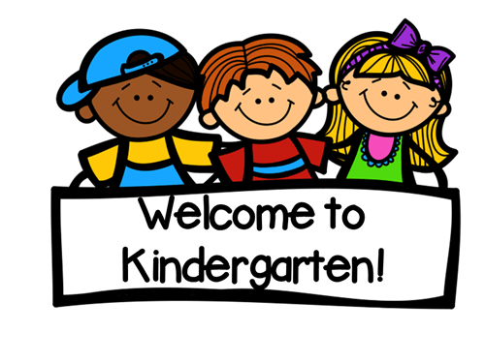
Thank you for your trust with your most precious gift. We look forward to helping your child learn and grow!

